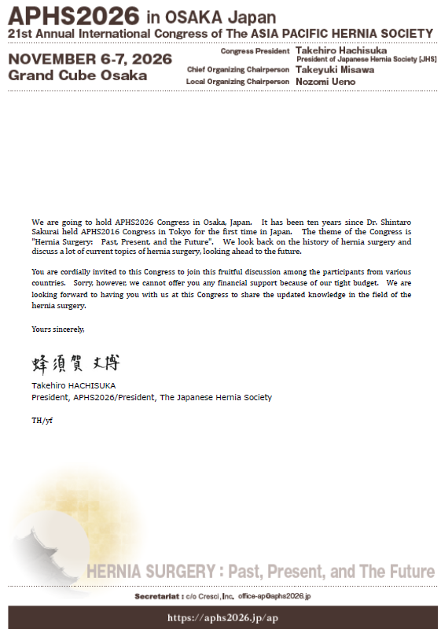
Month Date, 2026

Name
Affiliation
Address
Nation
Dear Name of applicant:

